Branding

## **3 core values**

* Curiosity/Diversity (learning about new themes/clients/experiences)
* Creativity
* Bold

## **Associations**

* Cats -> Just like cats, we are also very curiosity driven people, who are eager to explore.
* Humor -> We want to combine the teams’ humor through creativity, always adding fun twists in our projects.
* Courage -> Courage and being bold are important to us since these mean no matter how absurd an idea sounds, we are down to do it.

## **Mission (why do you exist, what do you do as a company)**

* “We create bold, human-centered designs from websites to apps to digital experiences, that feel alive and spark curiosity. By blending courage with playfulness, we help brands break routine and connect with people in fresh, unexpected ways.” version 1.0
* “We create. Meaning we slam boldness on the table, whether it be scratch of modern design or an explosive out of the box, in your face. This not only adds to that “special” personality you’re looking for in your digital experiences but also feel alive, quirky and unexpected.” version 2.0

## **Vision (what is your impact on society**)

* "We create bold, playful designs that break routine and make people feel free to step out of the ordinary and embrace the unexpected with joy."

## **Brand names**

* WhiskerWorks
* Claw & Craft
* Whisker Quest
* CurioPaws - ||
* Whiskerline-|
* WhiskerMind
* Savage Purr - |
* Pawwsible
* WhiskerSpark
* Catchee - |||||
* KitQuest
* WhimsiCat
* SparkTail
* Purradox
* Cattitude - |||
* Meowfia
* Katrix
* Purrpose
* Katapult
* Mewmentum

## **Pay-off (slogan)**

* Are you a shitter? Come in our litter. - |
* We will catch you in our paws and help you further.
* So good, its catchy.- |
* Too catchy to ignore. - |||
* Bold ideas, catchy designs. - |||||
* Designs that make you purr. - ||||||
* Designs that make you hiss. - ||||||
* Designs that make you meow. - ||||||

## **Chosen brand name**

* Catchee

## **Chosen slogan**

* “Designs that make you purr.”

## **Logo**

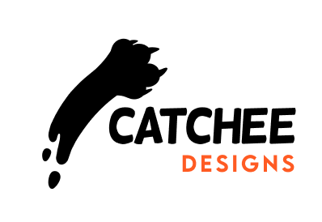

## **Base colours**

* Orange
* White
* Black

## **Accent colours**

* Blue

## **Typography**

* Logo: Helsinki
* Title & logo: Lemon Milk Medium
* Regular text: Amiko

## **Moodboard**

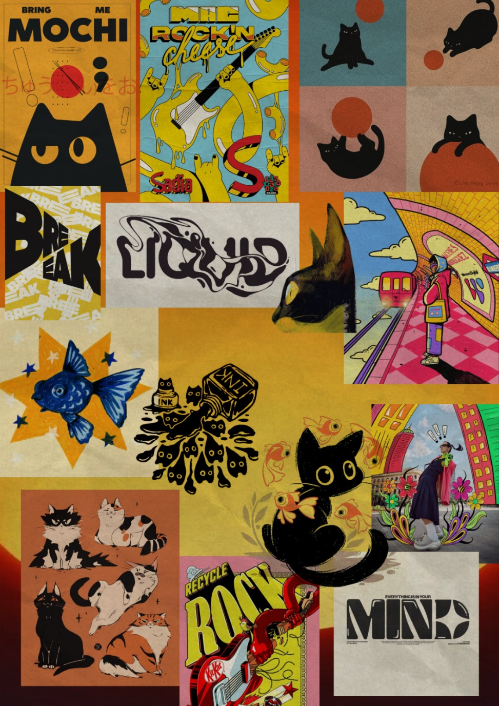

## **Stylescape**

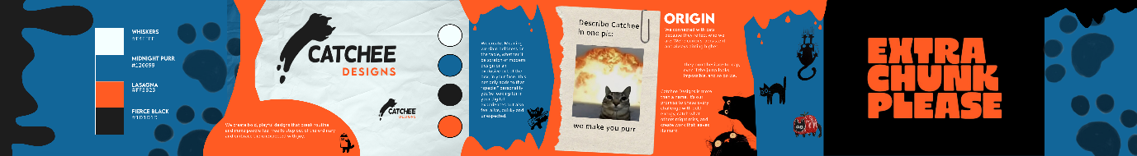

## **Poster**

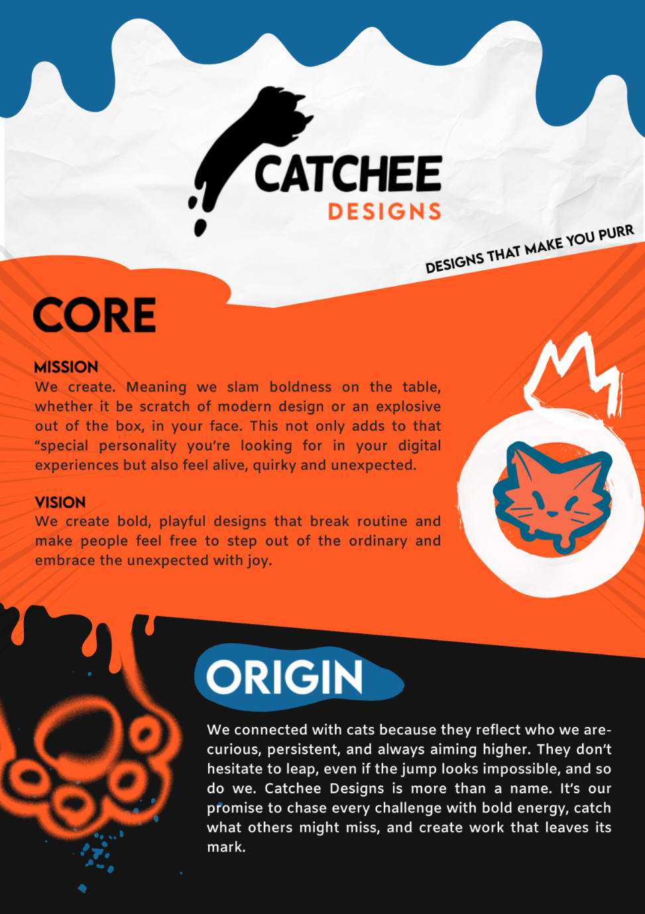

## **Brand guide**



## **Content strategy**

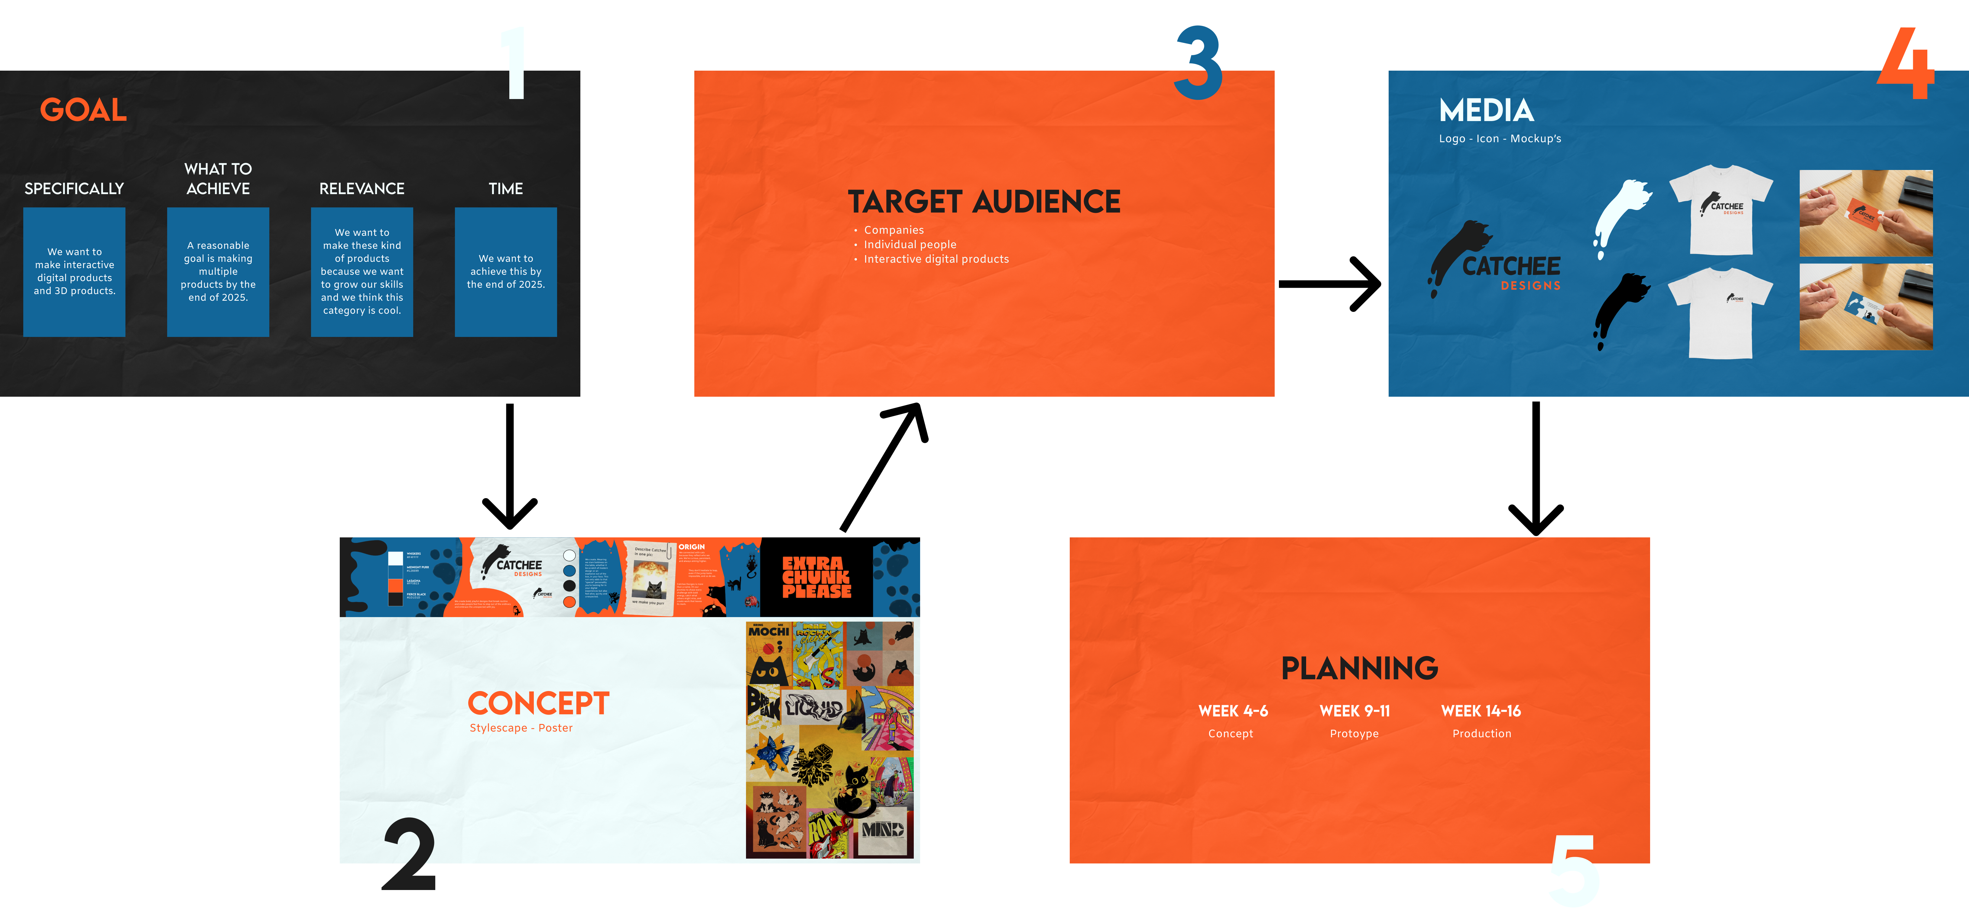

## **Tone of voice**

* **Semi-formal + Bold + Creative**

*Example: We don’t just solve problems; we rewire the way they’re thought about. Our team blends strategy with scratches of imagination, turning complex challenges into sleek, powerful and* ***Catchee*** *solutions. If you’re ready to move past the ordinary, you’re in the right place. PURR"*

## **Visual representation**

* Pitch: "We’re not here to blend in. We’re here to break routine. Our agency thrives on three things: curiosity, creativity, and boldness. Curiosity pushes us to dive headfirst into new themes, industries, and perspectives, no challenge is off-limits. Creativity is the fire that makes our work feel alive, playful, and unforgettable. And boldness is our trademark: we slam daring ideas on the table and craft websites, apps, and digital experiences that hit harder and connect deeper. We don’t just design, we create moments that spark curiosity, ignite joy, and make people step out of the ordinary. Our vision? A world where brands dare to be different, where people embrace the unexpected, and where digital experiences don’t just exist, they explode with energy. That’s what we stand for. And that’s why we’re the agency that brands call when they’re ready to make a bold move."